1. Find the candidates who came from source of LinkedIn . This helps to market the jobs more to linkedin to attract Talent.

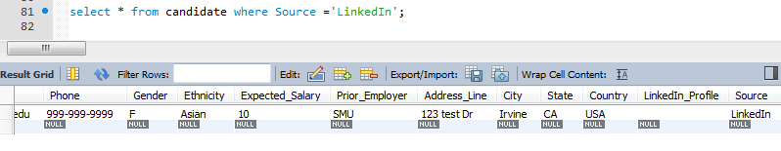

1. Show are Exempt jobs posted in the company.

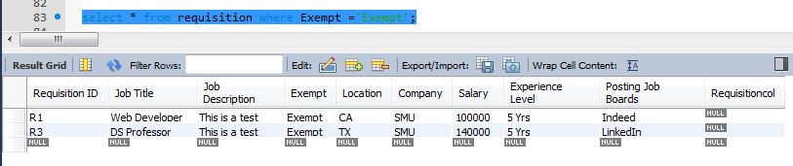

1. Show all candidates details who have applied to Requisition R1.

